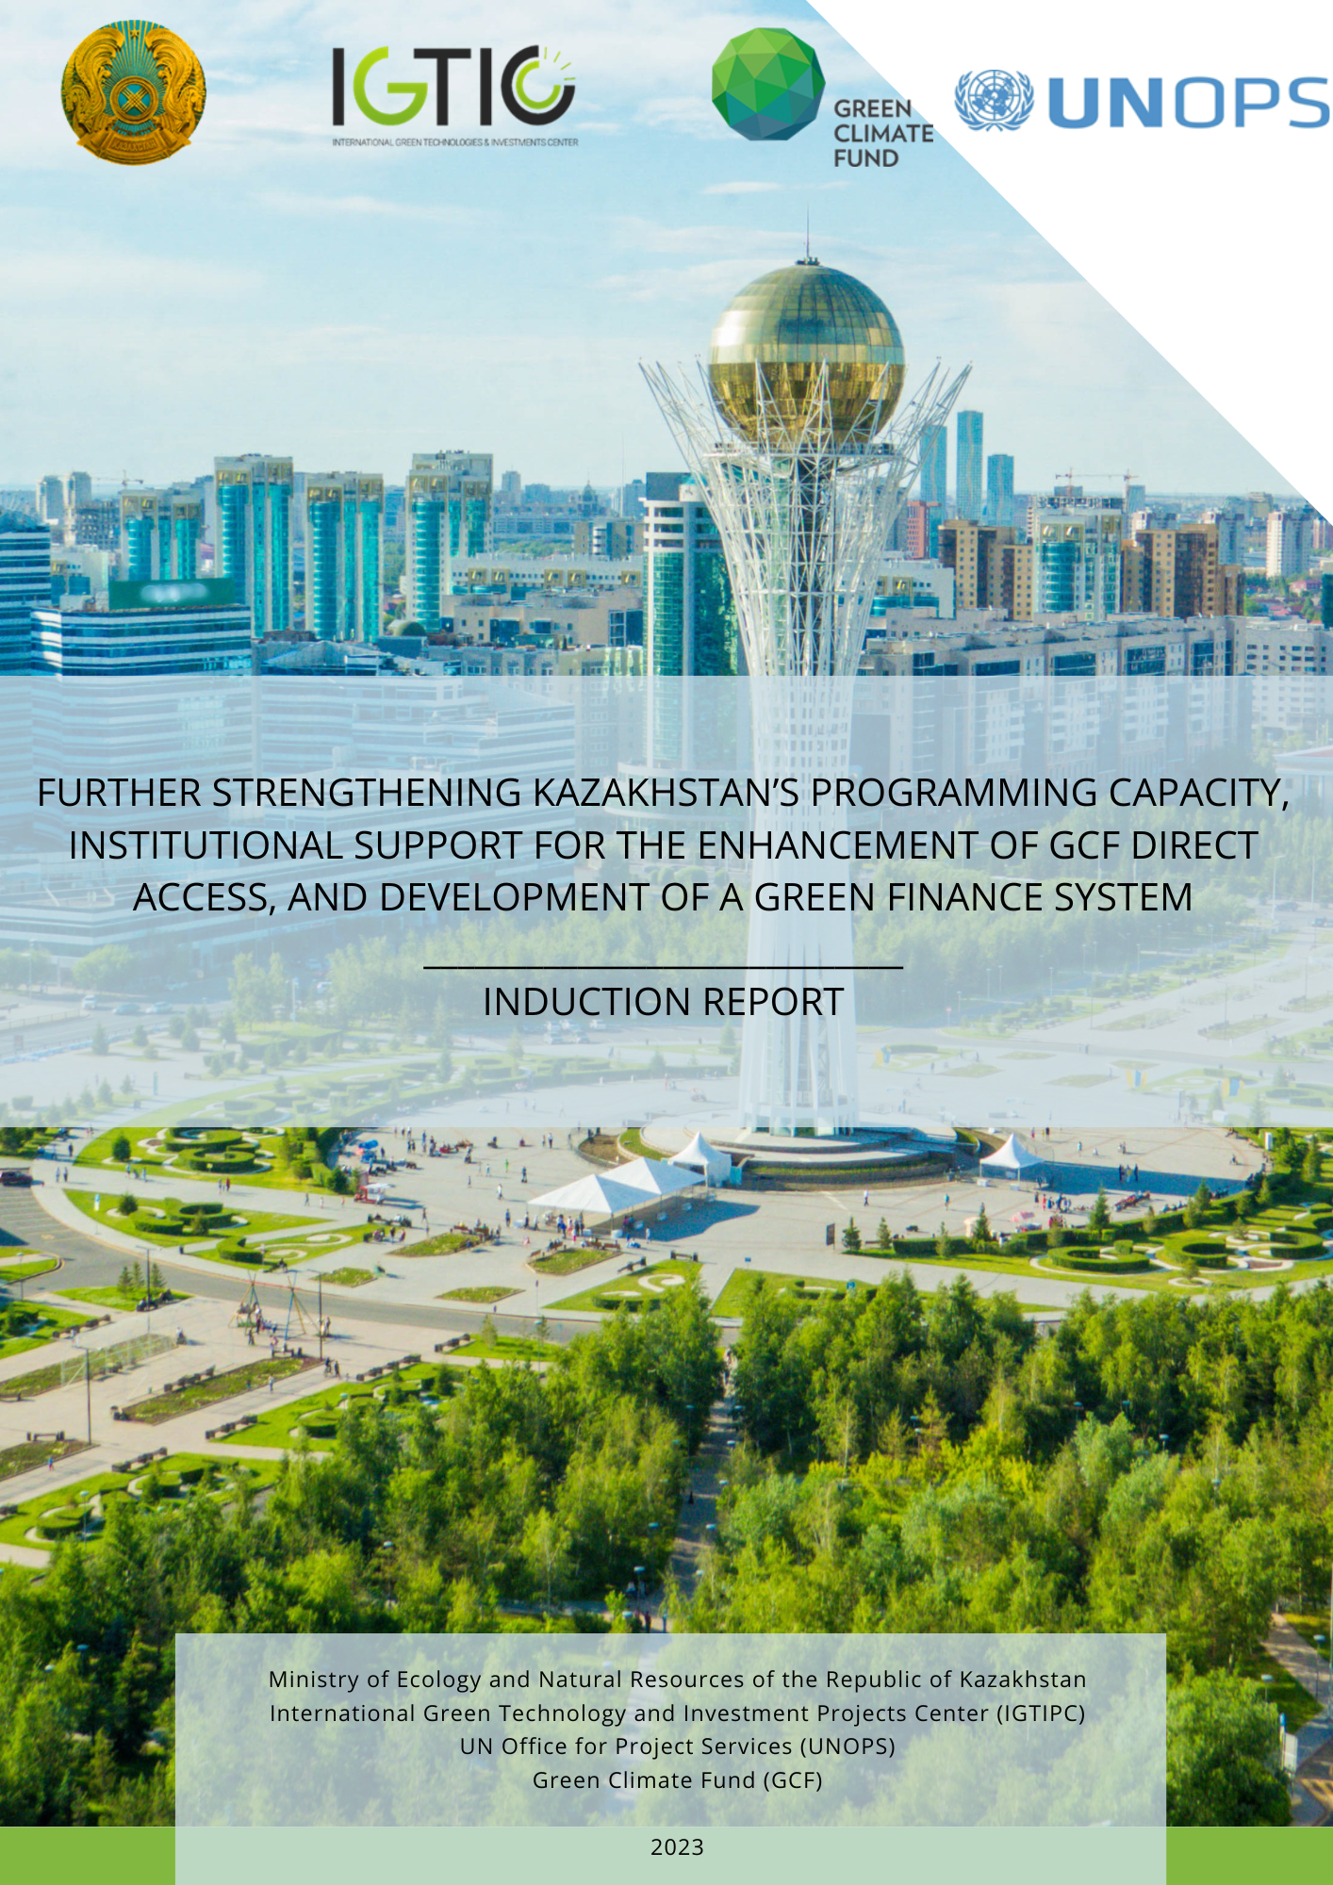

Table of contents

Table of contents 2
List of abbreviations 3
I. Project Summary 4
II. Project Background 6
III. Purpose of the Induction Report 7
IV.Overview of the induction workshop 7
V. Key concerns 8
VI. Project risk assessment and risks associated with risk mitigation 14
VII. Budget revision 23
VIII. Monitoring, evaluation, and reporting 23
IX. Recommendations 23
Appendix I: Agenda, list of participants, media, photos 24
Appendix II: Revised Logic Matrix 32
Appendix III: Revised budget attached as a separate file in excel format 46

List of abbreviations

AIFC International Financial Center "Astana"
ARDFM The Agency of the Republic of Kazakhstan for Regulation and Development of Financial Market
CAB Coordination and Advisory Board
CP Country Program
DAE Direct Access Entites
E&S Environmental and Social
ESG Environmental, Social, and Governance
ESS Environmental and Social Standards
EU The European Union
GCF Green Climate Fund
GDP Gross Domestic Product
GHG Greenhouse gas
IGTIPC International Green Technologies and Investment Projects Center
IR Induction Report
LEDS Low Emissions Development Strategy
LLDC Landlocked Developing Country
NBK National Bank of Kazakhstan
NDC Nationally Determined Contributions
NDA National Designated Authority
NMHS National Meteorological and Hydrological Services
UNFCCC United Nations Framework Convention on Climate Change
UNOPS United Nations Office for Project Services
WMO World Meteorological Organization

I. Project Summary

Project Name: Further strengthening the Kazakhstan’s programming capacity, institutional support for the enhancement of GCF direct access and development of green finance system (Readiness II Project)
Brief description of the Project: The Readiness II project aims to strengthen the country's capacity further and create an enabling environment for increased participation in the GCF and the attraction of climate investments. The Project will strengthen the ability of the National Designated Authority (NDA) to effectively and efficiently perform its functions, facilitate the successful completion of the accreditation process in the GCF by direct access entities, and thus open access to GCF funds to address climate change challenges in Kazakhstan, allow the development of an updated country program with a clear framework of priority climate change investments and project portfolio, and strengthen sustainable financing practices in the financial sector of Kazakhstan.
The Project provides for the following tasks:
Objective 1: Capacity Building
Build the capacity of various stakeholders, including the national government (Outcome 1.1), Direct Access Entites - DAEs (Outcome 1.2), and the broader private/industrial sector (Outcome 1.3).

Outcome 1.1 includes the establishment of a permanent Coordination and Advisory Board (CAB or Board) as formal institution to enable systematic coordination between NDA and many stakeholder; and updating its mandates, rules and procedures, including the no-objection procedure to address the latest regulatory and institutional changes.
Outcome 1.2 provides capacity building support for potential DAEs to enable their accreditation with GCF.
Outcome 1.3 targets private sector actors, including banking and corporate sector; and establishes the community of practice. For banking sector and financial institutions, the Project provides expert support for incorporating environmentally and socially conscious approaches and guidelines into banks’ policies and operational modalities, in particular, green lending and environmental and social risk management practices. For corporate sector, the outcome supports transformational measures across seven identified and prioritized sectors with the largest specific weight in the share of Kazakhstan’s GDP (steel and non-ferrous metallurgy, non-metallic mineral products, chemical and chemical products, food, cement, energy sectors) to drive climate resilient and low carbon growth in Kazakhstan. The abovementioned sectors play important role in the Kazakhstan’s economy and their share in terms of energy intensity and air pollution worth considerable value. The Project will help companies improve their competence in obtaining loans from international financial institutions, including the GCF; and improve their competence in transition to sustainable pathways (help companies implement plans for decarbonization. Furthermore, the Project will identify industrial leaders, enhance organisational structures through the establishment of decarbonization offices, and will create mechanism for the dissemination of good decarbonization practices among corporate sector.
Objective 2: Strategic framework
Outcome 2.1 is related to updating the GCF CP. Since the last submission of the draft country programme to the GCF, the national environmental policy has undergone several changes. The Government is currently revising its Nationally Determined Contributions (NDC) and developed Low Emissions Development Strategy (LEDS), which would lay out further climate action priorities at the national level. Additionally, the new Environmental Code (containing, among others, two separate chapters on mitigation and adaptation actions to climate change) was adopted by the Parliament in 2021. Consequently, the Country Programme should adequately reflect changes in country’s vision and strengthened environmental regulation and policy. The Country Programme and its pipelines should also be updated in line with the updated NDCs. The project pipeline is likely to be adjusted considerably to reflect the enhanced ambitions and better alignment with the GCF requirements and standards, which was one of the main feedback points on the initial draft of the Country Program. The updated Country Programme will also be aligned with the latest GCF requirements for the development of country programmes, which were endorsed by the Board in January 2021.
This outcome also includes an assessment of the performance of National Meteorological and Hydrological Service (Kazhydromet), its operating environment, and its contribution to high-quality weather, climate hydrological, and environmental information services and warnings
Outcome 2.2 is focused on improving the financial regulatory frameworks, including inter alia information disclosure and reporting requirements, and developing a vision for better integration of green finance issues within the existing operations of banking sector. The financial regulator supports the development of sustainable finance agenda in Kazakhstan, however, there are no formal plans or guidelines for its endorsement in practice..The banking sector in Kazakhstan still plays a limited role in the development of a green economy - there is no formal data collection by banks to track green financing flows in Kazakhstan to estimate the contribution towards Kazakhstan’s Nationally Determined Contribution (NDC).
Outcome aims at assessing the existing impediments for green finance development, and supporting the financial regulator in establishing a vision for green finance strategy to support Kazakhstan’s efforts to develop a sustainable financial system aligned with its climate and green development targets. Establishing robust green finance reporting system to support the wider deployment of sustainable finance instruments.

Implementing Institution: International Green Technologies and Investment Projects Center non-commercial joint-stock company

Project start date: November 10, 2022.
Project end date: May 09, 2024.
Project proposed completion date: September 09, 2024
Funding for the GCF project: $998,873

II. Project Background

Kazakhstan is Central Asia's largest economy with vast natural resources. The country is vulnerable to natural disasters, including droughts, heat waves, floods, mudslides, and landslides, which lead to land degradation, infrastructure damage, and loss of life. Maintaining agricultural productivity is also increasingly challenged by climate change, including changes in rainfall patterns, lengthening seasons, and an increased risk of pest and disease infestation. Negative climate trends are expected to exacerbate the impacts mentioned above; for example, a 2-3°C increase in temperature will lead to a reduction in vegetation cover, which, combined with an increase in heavy precipitation and melting glaciers, is estimated to increase tenfold the likelihood of mudslides.
As a Landlocked Developing Country (LLDC), Kazakhstan is very vulnerable to global climate change, so it is critical to have strict mitigation and adaptation policies in place. Kazakhstan joined the UNFCCC and the Kyoto Protocol and voluntarily committed to quantitative greenhouse gas (GHG) reductions to contribute positively to global action on climate change.
In October 2022, the UN Office for Project Services and the International Green Technologies and Investment Projects Center launched a new project entitled "Further strengthening the Kazakhstan’s programming capacity, institutional support for the enhancement of GCF direct access and development of green finance system". This Project is funded by the Green Climate Fund (GCF) and aims to achieve the following:
- Further strengthen the capacity of the NDA, including improving the operational efficiency and effectiveness of its respective networks/systems by establishing a permanent coordinating body consisting of the NDA and other relevant stakeholders;
- Building the capacity of direct access entities to help them meet and maintain the standards for GCF accreditation. This will be achieved by providing expertise and policy support to direct access entities;
- Capacity building for relevant stakeholders, including the private sector (key sectors: metals and non-ferrous metals, non-metallic mineral products, chemicals and chemical products, food, cement, energy sector), financial regulators, and banking and financial institutions to support them in the planning, programming, and implementation of GCF-funded activities. This will be accomplished through a series of trainings and the development of a customized media strategy to raise awareness among relevant stakeholders;
- Review and adoption of the Kazakhstan Country Program in line with the country's updated climate policy, strategies, and new approaches included in the latest environmental legislation. The updated Country Program will be reviewed by the GCF and endorsed by members of the coordinating mechanism and the GCF Climate Investment Committee;
- Strengthen sustainable finance practices in Kazakhstan's financial sector by developing guidelines and tools for defining green finance, green lending, and environmental and social risk management in banks, including ensuring greater engagement with GCF and GCF-financed activities.

Throughout the Project, the project document should be used as the basis for planning, goal setting, action mapping, and ongoing project management and evaluation. The Project results framework in the project document is a critical tool for all these areas because it clearly defines the specific indicators and targets against which project performance at the intermediate and final stages will be directly measured.
Due to a specific period between the approval of the Project and the beginning of implementation, the project document is mainly relevant. At the same time, there have been some changes concerning the project objects in green finance market development. The Induction Report provides more detail on the wording of some of the project results, revises the project activities, and proposes specific recommendations for project implementation.

III. Purpose of the Induction Report

This Induction Report (IR) is to recommend project measures that will help the project reach key milestones in a timely manner and ensure that the overall technical direction of the project during this phase is maintained and flexibly adapted to meet the practical challenges that arise during implementation.

As part of the delegation, the International Center for Green Technology and Investment Projects (ICGITP) provides ongoing assistance and oversight to the project team.
The implementation of the Project is carried out by the project team (project team): Project Manager and Administrative & Financial Assistant, who were hired in February 2023.
The project office is located in Astana wich is provided by IGTIPC. No other project office is foreseen, but project staff will travel on business as needed. Consultants and national partners will also assist with project presence outside of Astana.

The changes and activities during the project inception phase were also considered while conducting the workshop. This approach has provided the workshop conclusions and recommendations with a broader perspective and validity.

IV.Overview of the induction workshop

March 29, 2023, with the support of the Ministry of Ecology and Natural Resources, IGTIPC, and International Financial Center "Astana," held an Induction workshop, which presented the goals and objectives of the Project, components, and main activities, discussed priorities and changes in the Project. The agenda and list of participants of the Induction workshop are given in Annex I.

Participants commented on the need and relevance of the Project, aimed at strengthening the country's capacity and creating an enabling environment for greater participation in the GCF and attracting climate investment. The Project will strengthen the ability of the NDA to effectively and efficiently perform its functions and facilitate the successful completion of the accreditation process in the GCF by direct access entities.

A representative of the Ministry of Ecology and Natural Resources of the RoK emphasized the importance of the Project and that the Project will promote green projects through state support and the direct inflow of international and national investments.

Workshop participants reviewed the developed project strategy, components, and activities under the Project Results and Resources Framework and provided positive feedback on the project implementation strategy. During the Induction workshop, opportunities for collaboration with ongoing and upcoming initiatives in the country were also discussed in detail. Updates and modifications to the Project's logical framework were discussed among stakeholders.

V. Key concerns

The critical project beneficiaries and other stakeholders have confirmed the need for the Project and the relevance of its objectives, results, indicators, and targets.

More than three years have passed since the development and implementation of the Project; during this period, several events were carried out by the stakeholders, and by the time the Project started, these outcomes were either completed or were in the stage of completion, so the financial regulator, independently, has already prepared a number of documents, including a road map, ESG risk management guide, and ESG disclosure guide.

Key concerns raised during the Induction Workshop consider aligning the project activities for objectives 1 and 2 to avoid duplication of works and inefficient use of resources and project extension.

At the beginning of December 2022, the Prime Minister and his cabinet resigned. The new Minister of Ecology and Natural Resources was appointed in January 2023, and the new Vice-Minister, responsible for directing climate change work, was appointed in February 2023. In this regard, the Project started with a delay.

Due to a reasonable delay with the Project start, the non-cost extension of the Project is required. In this regard, extending the Project for four months, without changing the overall budget, is proposed to enable the Project to achieve and secure sustainable results.

Moreover, it is proposed to change the activities to meet the changing conditions. The results of the activities in developing the Sustainable Finance Roadmap for Kazakhstan and developing ESG risk management guidelines at this stage are redundant. In this regard, revising the relevant capacity-building activities for the banking sector is also necessary.

Also, Kazhydromet, before the Project, received financial support from the World Bank to prepare a report on the diagnosis of hydrometeorological services of Kazakhstan, and in this regard, the result 2.1.2 at this stage should be reviewed.
In this regard, the logical matrix is revised Annex II.

Objective 1: Capacity building
As noted in the project document, this component of the Project includes several activities aimed at building the capacity of various stakeholders, including the national government, banking, and the corporate sector.
The Project provides expertise for the banking sector and financial institutions to incorporate environmentally and socially conscious approaches and guidelines into banking policies and practices, particularly sustainable lending and social risk management practices.
In addition, potential banking and sovereign issuers (both at the national and local level) need to better understand green/sustainable bond market opportunities and implement appropriate green and sustainable bond policies, including external assessment aspects. The Project will help banks improve their competence in offering green products and attracting financing from international financial institutions, including the Green Climate Fund and capital markets.
The result supports transformational measures for the corporate sector in the seven identified and prioritized sectors with the largest share of GDP in Kazakhstan to ensure climate-resilient and low-carbon growth in Kazakhstan.
Consideration will be given to establishing a permanent Coordination and Advisory Council as an institution for systematic coordination between the NDA and many stakeholders; and updating its mandates, rules, and procedures, including a no-objection procedure, to reflect recent regulatory and institutional changes.
This component will also provide capacity-building support to potential DAEs to ensure the GCF accredits them.

Although the structure of intermediate and final outcomes under Task 1 remains unchanged, for the above reasons, it is necessary to revise activities A 1.3.2 and 1.3.3 on capacity building for the banking sector.
Table of changes: (Тhe table shows the changes for measures 1.3.2 and 1.3.3)
No. | In the project document  (original) | Proposed changes | Justification and Comments
1. | Output 1.3.2: Capacity of financial regulators, banking sector and financial institutions to report on green loans is strengthened via the practical training (involves use of audio and visual): | Output 1.3.2: Capacity of financial regulators to report and supervise green finance operations is strengthened, banking sector and financial institutions capacities to implement and report on ESG risk management and green finance as well as to assess whether a project meets nationally and internationally agreed-upon criteria for climate finance and related climate risks are strengthened: | Additional review of the challenges and capacity gaps in the capacity building of financial regulators and banking sector was conducted. Given that ARDFM is currently working on introducing ESG principles in the financial sector with IFC assistance, including the ESG Disclosure Guideline for financial institutions (to be adopted in 2Q 2023), ESG risk management recommendations for financial institutions (to be adopted Q2 2023), and plans to develop carbon accounting methodology in the years to come, there is a need in specific ESG and carbon footprint disclosure/reporting tools and successful pioneering and example setting cases of Environmental and Social Management System (ESMS) established in further implementation of aforementioned guidelines developed, as well as in a practical toolbox (preferably digital, web-based platform) that will help banks and other financial institutions to assess the climate eligibility and measure the climate impact of the projects they finance in national regulatory context. Such a toolbox would also allow banks to evaluate project compliance with various green standards (national and other taxonomies such as EU, Eurasian Economic Union, China) by collecting project information, greenhouse gas (GHG) emissions accounting information. Also, no formal definition of green loans has been adopted.
1.1. | A 1.3.2.1: Develop the practical training program taught in the classroom/online for ARDFM, NBK, banking sector and financial institutions:  - on green loan definition and green loan reporting guidelines tools and templates.  D 1.3.2.1 Finalised programs of practical training on green loans for ARDFM, NBK, banking sector and financial institutions | A 1.3.2.1: Developing one training program for pilot bank (including its Board of Directors, staff members and project implementers) and one awareness raising training program for a broader banking sector community:  - on developed model Environmental & Social Management system (ESMS) policies, as well as an Action Plan to guide the pilot bank through the implementation of its ESMS  - green loan portfolio labelling and implementation  D 1.3.2.1 The training programs for pilot bank and banking sector community
1.2. | А 1.3.2.2: Organise the trainings for ARDFM, NBK, financial institutions and banks in the area of green finance in line with the findings of A 2.2.2 including inter alia with involvement of international organisations working on green finance to ensure the best practices implementation:  - on green loan definition and green loan reporting guidelines  - tools and templates.  D 1.3.2.2 Report on two practical trainings for 30 experts from ARDFM, NBK, financial institutions and banking sector with a pre- and post-training survey of participants  (selection of candidates will be based on the gender equality principle) | A 1.3.2.2: Organise 2 trainings for 1) pilot bank and 2) banking sector community, including financial regulator representatives, in the area of ESMS, green loan identification and implementation, in line with the deliverables of A 2.2.2:  - on developed model Environmental & Social Management system (ESMS) policies, as well as an Action Plan to guide the pilot bank through the implementation of its ESMS  - green loan portfolio labelling in line with Kazakhstan taxonomy and implementation;  D 1.3.2.2: Training report on two trainings for 1) pilot bank (including its Board of Directors, staff members and project implementers) and 2) banking sector community (30 experts) with a pre- and post-training survey of participants (selection of candidates will be based on the gender equality principle)
1.3. | - | A 1.3.2.3: Developing and conducting training for banking sector and financial institutions on the use of the Climate Risk Assessment Toolbox, as well as assisting in the use of the Toolbox, including through the provision of technical backstopping and advice, in line with deliverables of A 2.2.3  D 1.3.2.3 At least 60 representatives of banking sector are trained on the use of the Climate Risk Assessment Toolbox (selection of candidates will be based on the gender equality principle)
2. | Output 1.3.3:  Capacities of financial regulators and banking sector to implement and report on E&S risks are strengthened via the practical training (involves use of audio and visual) | Output 1.3.3:  Banking sector, financial institutions and potential sovereign issuers’ capacities to develop and implement green and sustainable bond frameworks and issue green/sustainable finance instruments are strengthened | Project partners (ARDFM/IFC) are developing ESG risk management recommendations for financial institutions (to be adopted in Q3 2023), and plans to develop carbon accounting methodology using their own funding sources (co-funding), which make the E&S risk management guidelines and related training deliverable redundant at this stage, with the main focus shifting to further supporting the implementation of the Roadmap for sustainable finance approved by ARDFM and development of the sustainable finance market. Thus, potential banking sector issuers and sovereign issuers (both at the republican and local level) need to obtain better understanding of the opportunities of green/sustainable bond market and the implementation of related green and sustainable bond frameworks, including external review aspects. The project will help banks improve their competence in offering green products and raising finance from international financial institutions, including the Green Climate Fund, and capital markets.
 | A 1.3.3.1 Develop and conduct training for ARDFM, NBK, banking sector with involvement of international organisations working on sustainable banking to ensure the best practices implementation on the environmental and social risks management frameworks  D 1.3.3.1: Training report on two trainings for at least 60 representatives of ARDFM, NBK, banking sector trained on reporting, appraisal and management of E&S risks with a pre- and post-training survey of participants  (selection of candidates will be based on the gender equality principle) | A 1.3.3.1. Developing and conducting training for banks and financial institutions on development and implementation of green and sustainable bond frameworks and green/sustainable bond issuance, including external review aspects  D 1.3.3.1: At least 50 representatives of banking sector and financial institutions are trained on development and implementation of green and sustainable bond frameworks and green/sustainable bond issuance, including external review aspects [1 training]  (participants will be invited based on the gender equality principle)
 | - | A 1.3.3.2: Developing and conducting training for potential sovereign issuers (Ministry of Finance, local authorities) on development and implementation of green and sustainable bond frameworks and green/sustainable bond issuance, including external review aspects  D 1.3.3.2 At least 20 representatives of the Ministry of Finance and local authorities are trained on development and implementation of green and sustainable bond frameworks and green/sustainable bond issuance, including external review aspects [1 training]  (participants will be invited based on the gender equality principle)

Objective 2: Strategic framework
This component will support improved financial regulation in Kazakhstan and update the country's GCF program by enhancing the climate finance investment strategy through private sector involvement and conducting a Hydrometeorological Diagnostic of the country to determine future investment needs, improving NMHS‘s to address hydrometeorological issues, climate change, and other related problems and identifying opportunities for the DAE.
Under Outcome 2.1, support for Hydrometeorological diagnostics and identification of future investment needs is provided, as Kazhydromet, even before the start of the Project, received financial support from the World Bank to prepare a report on the diagnosis of hydrometeorological services of Kazakhstan and in this regard, the Outcome 2.1.2 at this stage should be reviewed.
Significant gaps exist in the availability of essential weather and climate observations, negatively affecting the quality of weather forecasts and climate predictions.
Due to climate change, the frequency and intensity of floods and other climatic factors are expected to increase, making it even more urgent to prioritize investments in an early warning and forecasting.
An early warning and forecasting system will provide information on the possibility and severity of impending hazards. It will help warn the population of the coming changes and allow timely preparation. The application of remote sensing systems at all stages of research and observation will make it possible to assess the extent of disasters and subsequently make important and precise management and crisis management decisions. The system can also be used to identify specific sites, zones, and population groups in need of priority assistance.
Regions often need more financial resources and technical skills to effectively monitor and respond to disaster risks. Supporting this area will help close the gap and provide communities with access to the necessary resources and technology provided by GCF activities, ultimately increasing their resilience and preparedness for disasters.
Access to GCF funds in this format will help enhance the state's ability to manage disasters and strategic planning in one of its highest-priority sectors.
Outcome 2.2
Improving the regulatory framework of the financial sector, including, among other things, disclosure and reporting requirements, as well as developing the concept of better integration of green finance into existing banking sector operations.
Since the financial regulator independently prepared a number of documents, including the Roadmap, ESG risk management guidelines, and ESG disclosure guidelines, it is proposed to change activities in the capacity building activities of the banking sector, financial institutions to develop and implement green and sustainable bonds policies and issue green/sustainable financing instruments, as well as other activities.
In particular, it is proposed to promote the national vision of sustainable finance through the implementation of appropriate systems and tools for tracking and reporting on green finance and the introduction of ESG principles by developing reliable templates for ESG-information disclosure and reporting on green finance to support the implementation of the financial regulator guidelines on ESG-reporting, environmental and social risk management systems, and carbon footprint accounting.

Table of changes: (The table shows the changes proposed for measure 2.1 and 2.2)

No. | In the project document  (original) | Proposed changes | Justification and Comments
1 | Output 2.1.2: Report on the diagnosis of hydrometeorological services of Kazakhstan, reviewed by a WMO member organization | Retrieved | KazHydromet, even before the start of the project, received financial support from the World Bank for preparing a report on the diagnosis of hydrometeorological services of Kazakhstan. In this regard, result 2.1.2 needs to be revised at this stage. Kazhydromet proposed the purchase of server equipment, which is impossible within the framework of the project.  In this regard, a new output 2.1.3 has been added. It is planned to consider a system of forecasting natural disasters, which will provide information about the possibility and strength of impending threats. The usage of remote sensing systems at all stages of research and observations will make it possible to assess the size of disasters and make essential and accurate management and anti-crisis decisions in the future. Also, with the help of the system, it is possible to identify specific objects, zones, and population groups that need priority assistance.
1.1 | А 2.1.2.1:  Conduct a CHD of the operating environment and technical capabilities of the NMHS of Kazakhstan in accordance with WMO requirements  D 2.1.2.1: Developed CHD report peer-reviewed by a WMO member organization  D 2.1.2.2: Summary report with information on capacity building, technical advice, investment portfolio, and/or other support needed to strengthen the NMHS | Retrieved
1.2 | - | Output 2.1.3 Design of a climate change disaster monitoring and forecasting system. Report and recommendations on the early warning and forecasting system in Kazakhstan.
1.3 | - | А 2.1.3.1: Prepare recommendations and design of the monitoring system and identify priority sectors using remote sensing systems  D 2.1.3.1 Analyze the system for predicting natural disasters in Kazakhstan and assess and determine which sites are most vulnerable.  D 2.1.3.2 Report on the monitoring system using remote sensing systems. Assessment and prioritization of the most vulnerable sectors and priority actions. Calculation of predictive modeling to assess the probability of occurrence of the most likely natural disasters and their potential consequences.
2 | Output 2.2.1:  The Sustainable Finance Roadmap for Kazakhstan is adopted by ARDFM: | Output 2.2.1:  Develop and approve simplified GHG Conversion Factors for Company Reporting (in Excel format) Tool for use by companies of Kazakhstan who are not a party of GHG reporting requirements within the context of UNFCCC Annex 1 framework with supporting Methodology Paper | The Sustainable Finance Roadmap has been developed in the begining of the project by project partners (ARDFM/IFC) using their own funding sources (co-funding), along with some ESG and carbon accounting guidelines developed or being currently developed by ARDFM/IFC in its implementation. As mentioned above, since this deliverable (Sustainable Finance Roadmap) has become redundant at this stage, the main focus of the work shifts to developing specific frameworks and tools on green finance, ESG risk assessment and carbon accounting methodolgy that would assist the implementation of the national vision for sustainable finance (Roadmap) and related regulatory framework: specifically, development of policies and action plan for a pilot bank on ESMS aligned with guidances developed/being developed by ARDFM, including green loans, development of simplified GHG Conversion Factors for Company Reporting Tool for use by companies of Kazakhstan (specifically requested by ARDFM), and a climate-related project assessment tool for the financial sector.  This particular Output (“Develop and approve simplified GHG Conversion Factors...“) was requested by ARDFM in support of its coming Guidance on carbon emissions accounting for the financial sector, citing lack of national carbon emission accounting tools for the purposes of corporate carbon reporting, and therefore, GHG emissions reporting in the financial sector
2.1 | A 2.2.1.1: Conduct and initial assessment of green finance practices (business models) of financial institutions to make sound policy suggestions, in close consultation with ARDFM, NBK and Kazakhstan Association of Financiers  D 2.2.1.1. Overview of policy options for stimulating the development of green finance market in Kazakhstan, e.g. indicating the international developments on sustainable finance in banking, insurance, capital market and applicable standards for Kazakhstani market | A 2.2.1.1: Conduct an overview of existing national and international GHG emissions calculation methodologies and conversion factors for possible application in the simplified GHG conversion factors tool  D 2.2.1.1. Nationally-specific conversion factors/indicators aligned with the national development strategies, climate targets and approved methodologies, as well as internationally recognized conversion factors/indicators that could be used in the GHG Conversion Factors Tool are identified
2.2 | - | A 2.2.1.2: Develop simplified GHG conversion factors for the purposes of company emissions reporting in a format of an Excel spreadsheet Tool and supporting Methodology Paper  D 2.2.1.2. The simplified GHG Conversion Factors for Company Reporting Tool in a format of an Excel spreadsheet Tool and supporting Methodology Paper is developed and submitted to stakeholders for consideration
2.3 | - | A 2.2.1.3: Conduct consultations with the Ministry of Ecology and Natural Resources, Zhasyl Damu and other stakeholders on the developed simplified GHG Conversion Factors for Company Reporting Tool  D 2.2.1.3. Developed GHG Conversion Factors for Company Reporting Tool and supporting Methodology Paper are adopted or approved as a guidance/recommendation at the level of either a ministry or authorized competent agency/institution (such as JSC Zhasyl Damu)
2.4 | - | A 2.2.1.4: Adaptation of relevant international standards and/or guidelines (translation into state and official languages of RK), that are necessary as supporting guidance in the use of the developed GHG Conversion Factors for Company Reporting Tool: World Resource Institute’s GHG Protocol standards (Corporate standard, Scopes 1, 2, 3) and Partnership for Carbon Accounting Financials (PCAF) Standard for Financed Emissions  D 2.2.1.4. GHG Protocol standards (Corporate standard, Scopes 1, 2, 3) and Partnership for Carbon Accounting Financials (PCAF) Standard for Financed Emissions are translated, with copyright permissions, and published for public access on official websites (such as websites of ARDFM, IGTIGPC, Ministry of Ecology and Natural Resources)
3 | Output 2.2.2:  Green Loan reporting is adopted by the NBK as a part of the reporting form on loans and piloted in pioneering | Output 2.2.2:  Development of policies and action plan for the pilot bank on environmental and social risk management, in implementation of ESG guidelines developed / being developed by ARDFM, including green loan labelling | As mentioned in the Comment No.1 to the Capacity building section of the Table of proposed changes above, there is a need in specific ESG disclosure/reporting tools and successful pioneering and example setting cases of Environmental and Social Management System (ESMS) established in further implementation of the Sustainable finance roadmap and related guidelines being developed by ARDFM, as well as in a practical toolbox to assess the climate eligibility of financed projects in national regulatory context. The overarching goal of the ESMS policies, to be developed for piloted bank will be to improve decision-making ensuring an adequate assessment of environmental and social risks and impacts of the proposed project activities and guidance to be applied during green finance implementation.
3.1 | A 2.2.2.1: Design Green Loan Attribute in line with the draft of Green Taxonomy of Kazakhstan and in consultations with NBK and Kazakhstan Association of Financiers  D. 2.2.2.1. The NBK loan reporting forms are updated | A 2.2.2.1: Selection of 1 bank based on a review of the current level of ESG principles adoption, preliminary negotiations and written commitments of candidates to further assist them in the implementation of an environmental and social risk management system, in pursuance of ESG guidelines developed / being developed by the ARDFM, including green loans.  D 2.2.2.1: At least 1 bank applies reporting with ESG principles (pilot project).
3.2 | A 2.2.2.2: Develop guidelines (Amendments to the NBK Reporting Rules) for the bank reporting purposes with tools, templates or a user guidance material.  D 2.2.2.2. A user guidance material is developed | A 2.2.2.2: Development of approaches regarding the green loan attributes for loans extended by banks in line with the Green Taxonomy of Kazakhstan: development of recommendations on the green portfolio labeling, a template for green loan identification, a template for green loan portfolio reporting and recommendations on the process of implementing green portfolio labelling.  D 2.2.2.2. Approaches and recommendations for green portfolio labeling in line with Kazakhstan’s Green Taxonomy, including related templates (for green loan identification and reporting), as well as a report on work performed, are developed and prepared
3.3 | A 2.2.2.3: Select 1 or 2 banks based on the A 2.2.2.1 outcome and recommendations of the NBK for testing the green loan attribute for reporting purpose.  D 2.2.2.3: List of the identified banks | A 2.2.2.3: Develop model Environmental & Social risk management policies (setting out approaches, responsible parties, principles, relevant instruments, description of processes and data requirements), as well as an Action Plan to guide the pilot bank through the implementation of its ESMS that will contain as a minimum: description of the required actions; definition of responsibilities; realistic timeframes for the completion of the actions, and required resources (staff and budget) as well as a monitoring system  D 2.2.2.3: Model Environmental & Social Management System policies, as well as an Action Plan for ESMS implementation, are developed
3.4. | A 2.2.2.4: Test the implementation of reporting guidelines, including inter alias through the provision of technical backstopping and advice  D 2.2.2.4: Report about Green Finance reporting systems established in 1 or 2 selected banks | -
3.5 | A 2.2.2.5: Conduct consultation with NBK and second tier banks on the developed Green Loan part of the reporting form and the guidelines  D 2.2.2.5: Report on the adoption of the Green Loan part of the reporting form and the guidelines by the NBK and second tier banks | -
4 | Output 2.2.3: Environmental and social due diligence principles are endorsed by banking sector and ARDFM | Output 2.2.3: A digital, web-based Climate Risk Assessment Toolbox is created and made available for financial institutions: | As mentioned in the Comment No.1 to the Capacity building section of the Table of proposed changes above, project partners (ARDFM/IFC) are developing an ESG Disclosure Guideline for financial institutions (to be adopted in 2023), ESG risk management recommendations (guidelines) for financial institutions (to be adopted Q2 2023), and plans to develop carbon accounting methodology using their own funding sources (co-funding), which make E&S risk management guidelines deliverable redundant at this stage, with the main focus shifting to further supporting the implementation of these guidelines, such as by developing a climate-related project assessment tool for the financial sector, since there is a need in a practical toolbox that will help financial institutions to assess the climate eligibility and measure the climate impact of the projects they finance in national regulatory context.
4.1 | A 2.2.3.1: Develop the E&S Risk Management Guidelines for the banking sector of Kazakhstan in consultations with ARDFM and Kazakhstan Association of Financiers based on the best E&S risk management practices and standards (e.g. IFC Performance Standards)  D 2.2.3.1: E&S Risk Management Guidelines for Banks are developed | A 2.2.3.1: Developing the methodological framework underlying the Climate Risk Assessment Toolbox (including accounting methods, formulas, emission factors etc. by sector, climate assessment benchmarks (EU, China, CBI, Kazakhstan), green taxonomies (Kazakhstan taxonomy, Eurasian Economic Union Taxonomy, CBI, China)  D. 2.2.3.1: Methodological framework for Climate Risk Assessment Toolbox (including accounting methods (formulas, emission factors etc.) by each sector, climate assessment benchmarks (EU, China, Kazakhstan), green taxonomies (Kazakhstan taxonomy, Eurasian Economic Union Taxonomy, CBI, China) is developed (in English and Russian)
4.2 | A 2.2.3.2: Conduct consultation with the ARDFM and banks on the developed E&S Risk Management Guidelines to collect the feedback  D 2.2.3.2: Report on adoption of the E&S Risk Management Guidelines by ARDFM | A 2.2.3.2: Developing the web-based platform for Climate Risk Assessment Toolbox, along with User guidance manual, and putting it in service for open use by financial institutions.  D 2.2.3.2 Web-based platform for Climate Risk Assessment Toolbox is developed and made available for use by financial institutions Climate Risk Assessment Toolbox, along with User guidance material is developed

VI. Project risk assessment and mitigation measures

The table below lists the risks, assessing their probability and potential impact of planned mitigation actions. The Project has one high probability risk and consequences that are operational in nature; clear mitigation strategies are provided. The remaining risks have one medium and the remaining low risks. Given the innovative nature of the Project and its high dependence on overall government support and national and local stakeholder capacity, the project manager monitors identified risks on a quarterly basis.

№ | Risk category | Specific risks Description of risks | Probability of occurrence (low, medium, high) | Level of exposure (low, medium, high) | Mitigation actions | The organization responsible for risk management
1 | Political | Loss of political support | Low | High | The Project is supported by the Ministry of Ecology and Natural Resources, which provides the best opportunity to ensure political support for the project objectives. All project activities will be discussed in consultation with the N  DA.  The Project promotes the positive effects of applying accessibility to green financing to the GCF: improved investment environment, job creation, and public health effects.  Continued sustainable support of the financial regulator, the NBK, and the Department of Methodology and Prudential Regulation of the ARRFR, taking into account the already developed Roadmap and willingness to support the consideration of sustainable financing initiatives and draft regulatory proposals under the Project.  Any changes and additional green finance policy and system proposals will be developed in close cooperation with the ARDF, NBK, and the Kazakhstan Financiers Association to ensure support and adoption. | IGTIPC, NDA
2 | Implementation | Limited obligations on the part of the designated DAEs | Low | High | Consistent with lessons learned from previous support of Direct Access Organizations (DAAs), IGTIPC will provide individualized support to select DAA candidates to ensure a full understanding of the scope of the necessary commitment and language requirements to secure accreditation in the GCF.  In addition to the technical requirements for accreditation, IGTIPC will identify and propose an RPA based on a clear vision of GCF participation, which should indicate an ongoing commitment to ensure accreditation.  In addition, IGTIPC will ensure ongoing communication with DAEcandidates to fulfill commitments.  In addition, the proposed support for potential EDSs will be with the completion of the application as the end result to reduce the risk of low EDS motivation and termination of further accreditation activities. | IGTIPC
3 | Technical and operational | The delay between the grant launch and consultant procurement | Low | Medium | Procurement risk will be mitigated by an effective Implementation Partner responsible for mobilizing the procurement of goods and services for project activities in accordance with internal procurement procedures. | IGTIPC
4 | Operational | Delays in implementation by consultants/suppliers | High | Medium | Project management procedures, fiduciary rules, and measures are in place. If possible, contracts will be signed with payment only after acceptance of services rendered. There will be fines and penalties for late performance.  IZTIP will coordinate closely with the NDAs and consultants to ensure timely implementation and will organize progress update meetings on an ongoing basis. | IGTIPC
5 | Legal | Prohibited acts, money laundering, or terrorist financing | Low | High | ICEM will follow the national legal framework regarding money laundering and terrorist financing or prohibited practices, as well as other relevant regulations, rules, and policies, including the anti-fraud and anti-corruption framework. | IGTIPC
6 | Sustainability of activities | Low level of sustainability of activities, for example, trainings and seminars | Medium | Medium | To ensure the sustainability of events such as trainings and workshops, there will be a survey of participants before and after the training. This will help identify areas to focus on and address gaps in the training/seminar course. | IGTIPC
7 | Force Majeure | Political and special events/disasters/epidemics | Low | High | Alternative methods of operation have been adopted to ensure the continuity of the Project safely and appropriately. | IGTIPC, NDA
8 | Covid-19 risk | Events are postponed or repeated because of inadequate data due to limited personal interaction and travel restrictions. | Low | Medium | Monitor the COVID-19 situation and assess possible implications for preparedness activities.  Data will be collected under national health and safety regulations. ICSTIP will provide tools for remote collaboration and cooperation as needed. The unused travel budget may be reallocated to supplement remote collaboration tools or additional related costs associated with the Covid-19 situation. | IGTIPC, NDA

VII. Budget revision

A detailed budget for the Project, including projected costs by component and category, was developed based on careful consideration of the activities to be undertaken, the expertise required, and the intended objectives.
Pursuant to paragraph 7 of the Budget Revision Agreement of the General Conditions of Grant Support Agreements on notification of changes in budget line items, planned expenditures from the contingency line item in the budget, and the transfer of funds between budget categories.
The amended budget is attached as per UNOPS Form, Annex II.

VIII. Monitoring, evaluation, and reporting

The Project will be monitored through the following monitoring and reporting activities.

On a day-to-day basis:
Regular monitoring of project results and risks, including social and environmental risks. Ensuring a high level of transparency, responsibility, and accountability in the NDA and Project results reporting.

Audit:
The Project will be audited in accordance with the internal Financial Regulations and Rules and applicable audit policies for DIM-implemented projects. Additional audits may be conducted at the request of the GCF.

Annual Project Report: The Implementing Partner will provide an annual report on the Project for the calendar year. IGTIPC will ensure that the indicators included in the project results matrix are regularly monitored so that progress can be included in the report. Any environmental and social risks and related management plans will be monitored regularly, and progress will be included in the report. Feedback on the previous year's report will be used both to update the project implementation strategy and to prepare the next report.

Final Report: The final annual project report will serve as the final project report package. The final project report package should be discussed with project management during the end-of-project review meeting to discuss lessons learned and opportunities for scaling up.

IX. Recommendations

Initial updates to the project document are required as some of the changes noted in IV Components and Planned Activities occurred during the project preparation process.
Key recommendations include:
- The Project Results Framework should be updated and endorsed in UNOPS, including clarifying and updating the wording of interim and final indicators to better reflect the essence of the indicators and prevent any misinterpretation of project phases.
- Review and approve the project budget in UNOPS, taking into account the changes made in the Project Structure and Carry-over IV. Components and planned activities.
- Extend the project by 4 months, without changing the overall budget.
- Inform the responsible national authority and other stakeholders about the updated Project Results Framework and the revised budget.

Appendix I: Agenda, list of participants, media, photos

 |  |  | 

PROGRAM
Induction Workshop on the Readiness II Project

Date of the event: March 29, 2023
Time of the event: 10:00 – 13:00
Format of the event: Hybrid
Venue: Pavilion C-3.2, London Hall, Mangilik el avenue, 55/18, Astana, Kazakhstan

Goal: Launch of the Readiness II project to further strengthen the country's potential and create favorable conditions for more active participation in the Green Climate Fund and attract climate investment. The project will enhance the ability of the National Designated Authorities to effectively and efficiently perform its functions, facilitate the completion of the GCF accreditation process by direct access entities, and thus open up access to GCF funds. It will strengthen the practice of sustainable finance in the financial sector of Kazakhstan by creating a favorable institutional environment and building the capacity of local experts.

Organizers: The Ministry of Ecology and Natural Resources of the Republic of Kazakhstan and "International Center for Green Technologies and Investment Projects" non-profit joint stock Company

The meeting will be a hybrid event held offline in cooperation with our AIFC partners and online via Zoom.

Follow the link on the day of the event to join the meeting:
https://us06web.zoom.us/j/82120029157?pwd=NlBRRzJFNjJwVHVmVjZLZm1lcHZMQT09

Conference ID: 821 2002 9157
Password: 006200

March 29, 2023
9: 30 - 10:00 coffee-break

Moderator: Victoria Baigazina, Project Coordinator, International Center for Green Technologies and Investment Projects
10:00 – 10:30 | Welcome Speech  Bekmagambetov Dosbol, Vice-Minister of Ecology and Natural Resources of the Republic of Kazakhstan  Agabekov Olzhas, Chairman of the Management Board of "International Center for Green Technologies and Investment Projects" non-profit joint stock Company  Daniyar Kelbetov, Member of the Board of the AIFC Administration
10: 30 – 12: 00 | The first stage of implementing the Readiness I project: results achieved and lessons learned.  Saulet Sakenov, UNDP Project Manager in Kazakhstan  Videoclip on the Country Program in the GCF  the Green Climate Fund  Presentation of the Readiness II project: main goals and objectives of the project Stages and implementation plans  Syrym Nurgaliyev, Project Manager of Readiness II  Presentation: Accreditation in the GCF  Aidar Yessembayev, Director of the Department of International Cooperation, "International Center for Green Technologies and Investment Projects" non-profit joint stock Company  Presentation: Building the capacity of the banking sector and financial institutions to use green finance tools and implement ESG reporting  Aigul Kusaliyeva, Director of the Department for Sustainable Development, AIFC Administration
12:00 – 12:30 | Questions and answers  Closing of the Induction workshop

LIST OF PARTICIPANTS
Induction workshop on the Readiness II project
March 29, 2023
52 offline, 66 online (118)

No. | Full name | Organization
 | Bekmagambetov D.B. | Vice Minister of Ecology and Natural Resources of the Republic of Kazakhstan
 | Agabekov O.P. | Chairman of the Board IGTIC MENR
 | Kelbetov D. | AIFC Managing Director
 | Kokbaeva A. | Director of the Department for Climate Change and Green Technologies of the Ministry of Natural Resources of the Republic of Kazakhstan
 | Sabieva S.S. | Deputy Director of the Department for Climate Change and Green Technologies of the MENR RK
 | Mammadaliyeva Aizhan | Department of Climate Change and Green Technologies of the MENR RK
 | Tastemirova Sh. | Department of Climate Change and Green Technologies of the MENR RK
 | Mukashova Enlik | Head of Department MMIR RK
 | Kalieva N. | Chief Expert of the Department of Nature Management of Atyrau Region
 | Maidan D. | Energy Saving Institute
 | Zhanadil Dina Zhailaubaevna | Development Bank of Kazakhstan
 | Omarova Perizat Tlegenovna | Development Bank of Kazakhstan
 | Berikkyzy Adina | Development Bank of Kazakhstan
 | Janadil D. | Development Bank of Kazakhstan
 | Tulepbekova A. | Development Bank of Kazakhstan
 | Khamitova Gulzhikhan Amerzhanovna | Bank Center Credit
 | Aidarbekova Aliya Karataevna | Otbasy Bank
 | Kumargaliev Alisher Medetovich | ALE "Association of Environmental Organizations of Kazakhstan"
 | Sukhonosenko Ilya Alexandrovich | ALE "Association of Environmental Organizations of Kazakhstan"
 | Zhaksibaev Maksut Ermekbaevich | Association of Greenhouse Gas Verifiers
 | Zhakanova Moldir Erlankyzy | Qazaqstan Investment Corporation
 | Madieva Saniya Amambaevna | Qazaqstan Investment Corporation
 | Asyl Okapova | Green Economy Coalition
 | Karimova Eldana Akhmetzhanovna | JSC NC KazMunayGas
 | Aitmagambetova Inzhu | JSC NC KazMunayGas
 | Ingerbayeva Zhanat | JSC NC KazMunayGas
 | Lakasova Aknur | JSC NC KazMunayGas
 | Ayman Yesekina | JSC Zhasyl Damu
 | Alisher Kasenov | JSC Zhasyl Damu
 | Kaliakbarov Serikbol Muratuly | JSC Zhasyl Damu
 | Zhakulin Azat Asautaevich | JSC Zhasyl Damu
 | Iskakova Kenzhegul | Samruk Energy
 | Melnik Larisa Borisovna | ESGQ
 | Bektasov D.E. | Samruk-Energy
 | Ibrahimov F. | CAREC
 | Ageeva D.K. | Baiterek
 | Sundetova A. | SBI Group
 | Omarbekova A. | SBI Group
 | Baigazina V. | Director for the Management Department of IGTIC
 | Nurgaliev S. | Project Manager, Management Department, IGTIC
 | Egemberdieva A. | Project Assistant, Management Department, IGTIC
 | Ugan J. | GCIP Project Assistant IGTIC
 | Bishimbayeva S. | GCIP Project Manager IGTIC
 | Esembaev A. | Director for the International Cooperation Department IGTIC
 | Kusalieva A. | Deputy CEO AIFC Green Finance Center
 | Takhanova M. | AIFC Green Finance Center
 | Kazbek Madina | ESG Invest LLP
 | Kazbek M. | ESG Invest LLP
 | Evniev B. | UNDP project
 | Nurzhan A. | UNDP
 | Mukhametraimova L. | Department of Ecology and Environment of Almaty
 | Posylanko N. | TOOEG

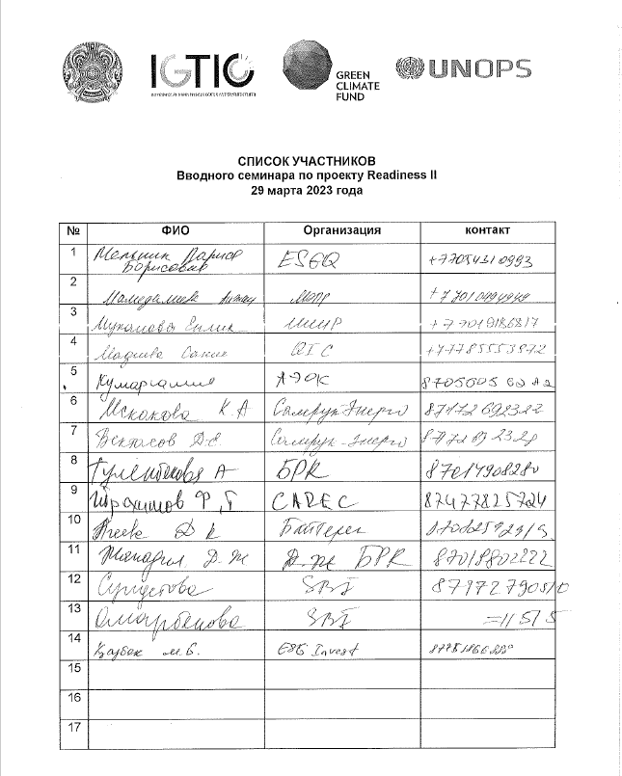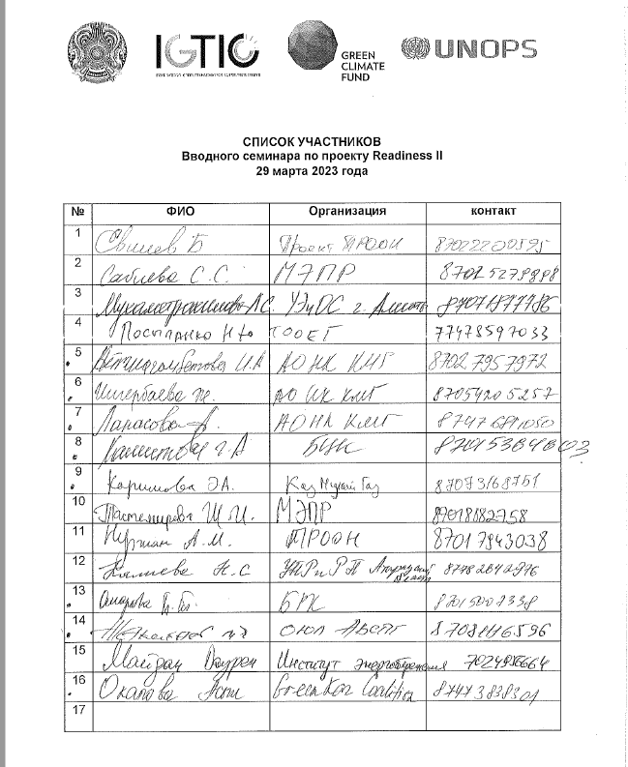

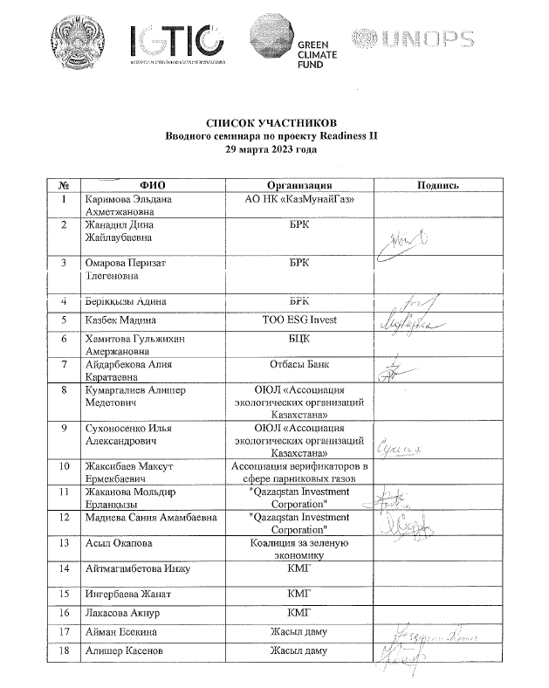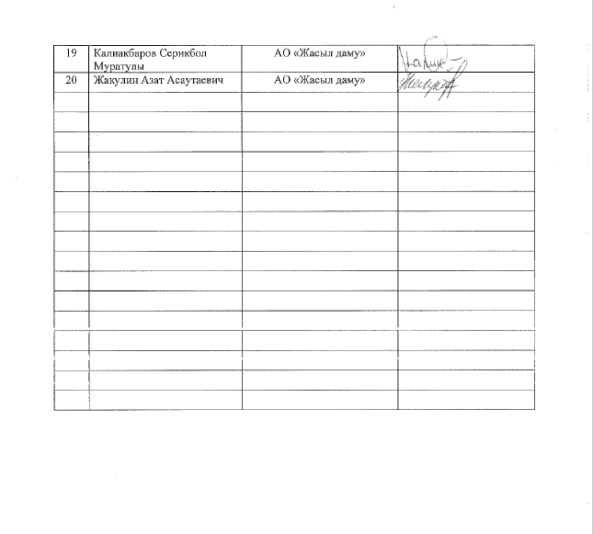

Lwist of accredited media outlets
# | Full name | Editorial Office
1 | Serdalina Aruzhan | "Newtimes.kz"
2 | Alina Aliyeva | BaigeNews
3 | Surganov Valery | Vedomosti Kazakhstana
4 | Almukhambetova Aliya (correspondent) | Eurasia
5 | Dastan Alishev (operator) | Eurasia
6 | Amanov Bekzat  (correspondent) | Khabar 24
7 | Baigazhanova Guldana  (correspondent) | Khabar 24
8 | Konyrbaev Serik  (operator) | Khabar 24
9 | Zharkyn Orden  (lighting technician) | Khabar 24
10 | Berdibekov Adilzhan  (special correspondent) | Atameken
11 | Zhakeev Murat  (special correspondent) | Atameken
12 | Zhunis Alibi-Erel  (operator) | Atameken
13 | Taldybek Aktore  (operator | Atameken
14 | Kadyr Diana  (correspondent) | Khabar
15 | Aubakir Ratmir  (correspondent) | Khabar
16 | Abildin Kanat  (cameraman) | Khabar

Media coverage
 | Link | TV Channel name | Language
1 | https://youtu.be/lsera_iWb-Q | Khabar 24 | Kazakh
2 | https://youtu.be/55iwxu9n3_0 | Khabar 24 | Russian
3 | https://youtu.be/gzdFhTMxbW0 | Khabar | Russian
4 | https://youtu.be/k4-fWzCuRUk | Khabar | Kazakh
5 | https://www.youtube.com/live/6LCmwUThEmM?feature=share | Atameken business | Russian

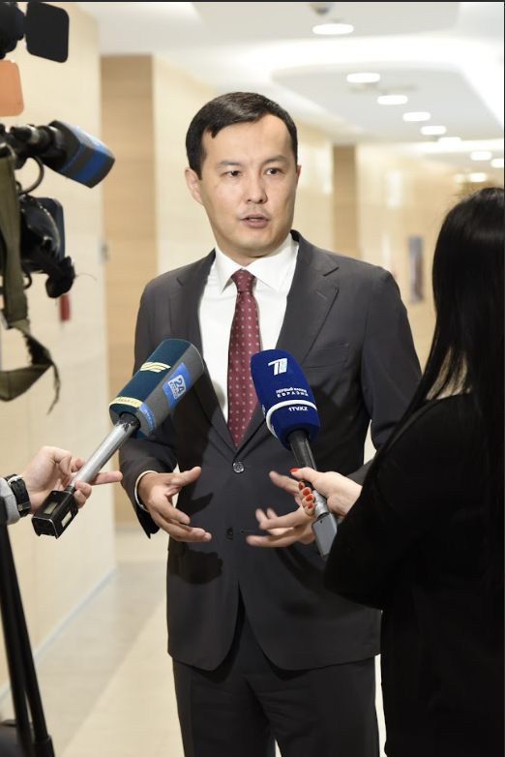
In the photo, Chairman of the Board of the "International Center for Green Technologies and Investment Projects" non-profit joint stock Company Agabekov Olzhas
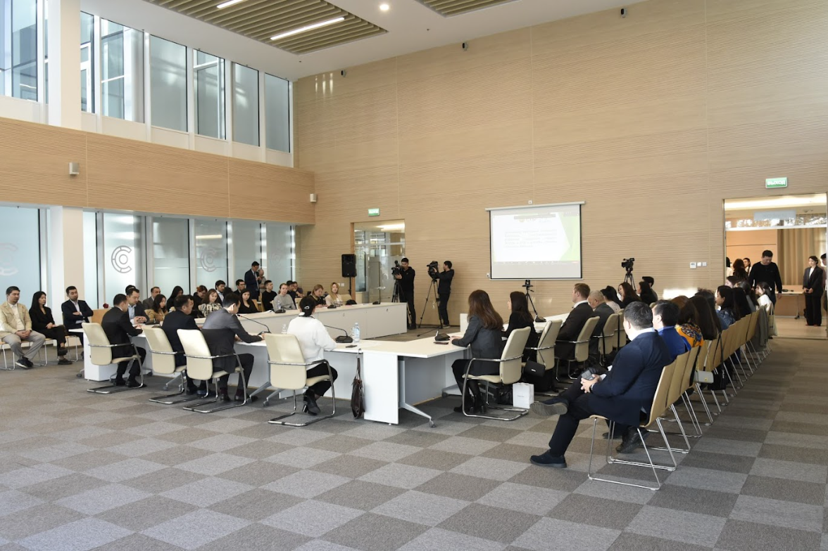
In the photo, participants of the Introductory seminar on the Readiness II project

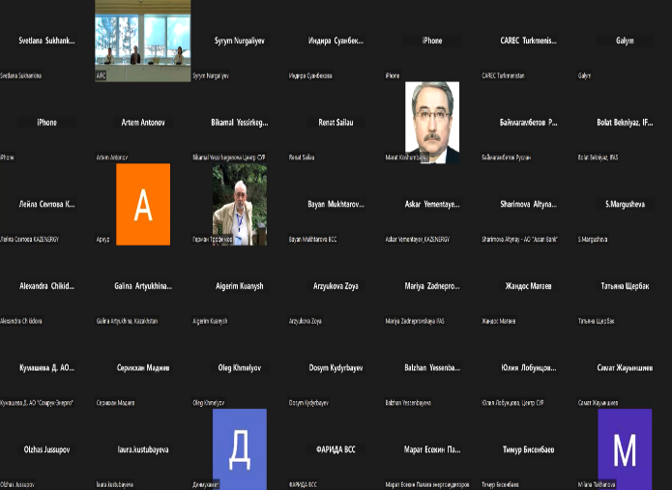
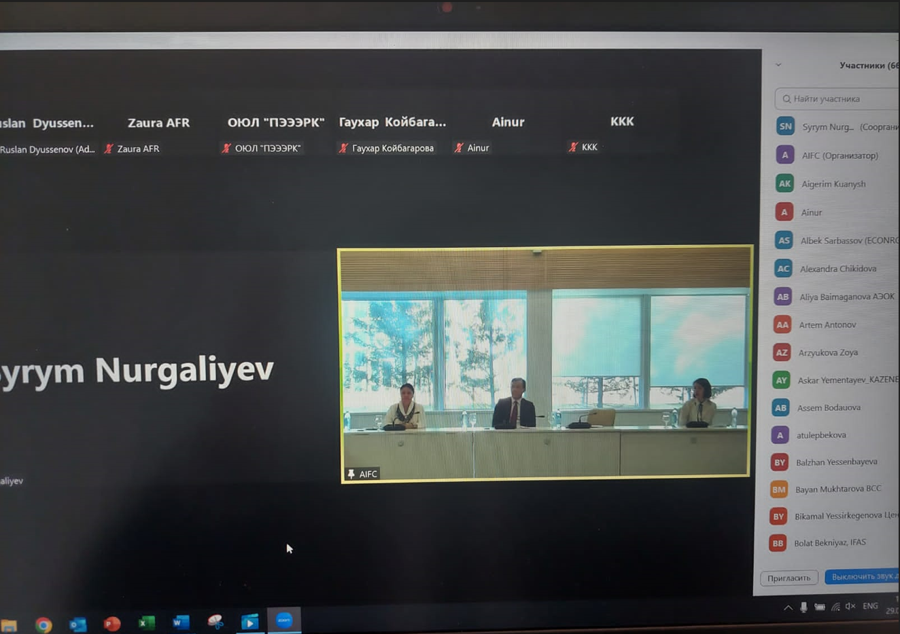
In the photo, participants of the Zoom conference of the Induction workshop on the Readiness II project

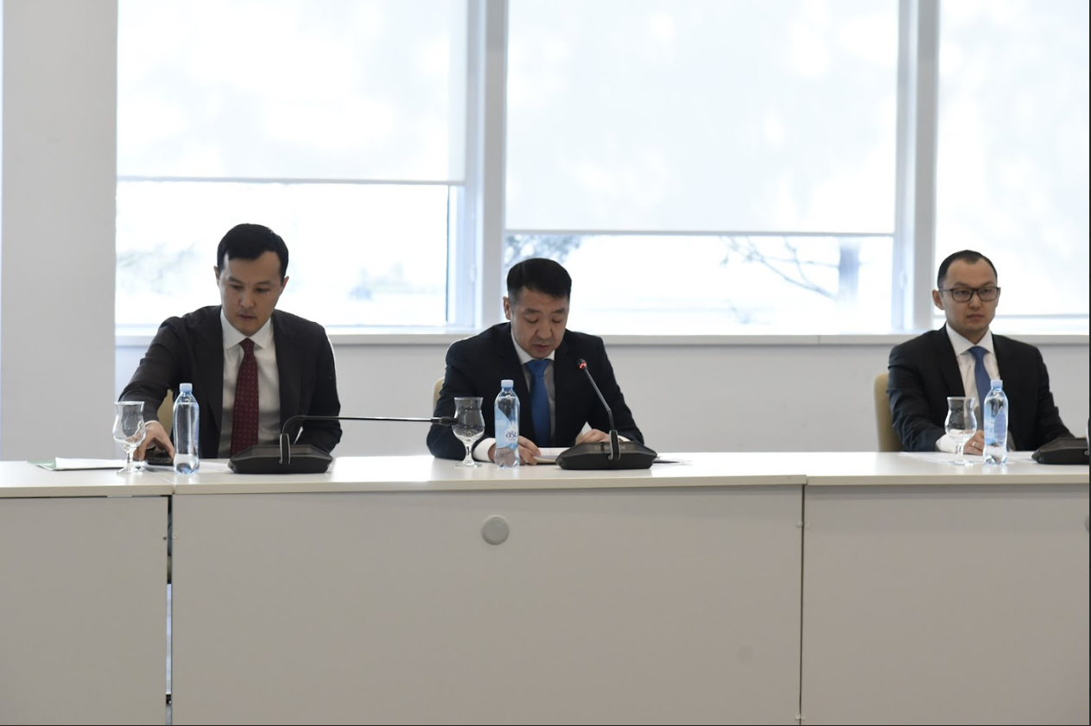
In the photo Vice-Minister of Ecology and Natural Resources of Kazakhstan Bekmagambetov Dosbol, Chairman of the Board of NAO "International Center for Green and Investment Projects" technologies Agabekov Olzhas and Managing Director of AIFC Kelbetov Daniyar

Appendix II: Revised Logic Matrix

Proposed changes in the logical matrix are highlighted in yellow and in green, made before the start of the Project.
The proposed wording does not change the essence of the indicators or targets but is intended to ensure their clarity so that the wording of the indicators and targets is self-explanatory.

Outcomes | Baseline | Targets | Outputs | Activities  (brief description) | Deliverables
Outcome 1.1:  Country NDAs or focal points and the relevant network/systems that enable them to fulfill their roles, responsibilities, and policy requirements are operational and effective | Initial documents were drafted and submitted for review and approval by government entities; however, the institutional and policy landscape has evolved, and further actions are required to enhance coordination and update the no-objection procedure. | A permanent coordination and advisory body consisting of NDA and other relevant stakeholders is fully functional and equipped with necessary rules and procedures of operation, and project appraisal frameworks, including the no-objection procedure. | Output 1.1:  A permanent coordination mechanism that permits the NDA to operate and fulfill its responsibilities, such as managing the no-objection procedure, is developed and operational. | A 1.1.1: Review the existing coordination gaps and develop a number of recommendations for the effective implementation of the coordination mechanism  A 1.1.2: Based on D 1.1.1. update documents regulating the activities of the coordination mechanism to improve coordination within the changed institutional and policy landscape  A 1.1.3: Conduct policy and institutional analysis to ensure the alignment of the no-objection procedure with updated policy frameworks  A 1.1.4: Update the no-objection procedure to reflect the latest policies and institutional frameworks  A 1.1.5: Deliver two trainings on the updated no-objection procedure for the key actors: NDAs, prospective permanent coordination body's members, DAEs, Accredited Entities, and other relevant stakeholders | D.1.1.1: Analysis and recommendations on improvement of existing coordination mechanism  D 1.1.2 a: Approved report with the Standard Operational Procedures for the Coordination Mechanism and affiliated committees and working groups are developed  D 1.1.2 b: Formal TORs for coordination meetings are developed  D 1.1.2 c: Work plans with associated milestones are developed  D 1.1.3: Approved report with definite recommendations for updating the no-objection procedure, including relevant decision-making and coordination procedures and project appraisal criteria developed and discussed by the key stakeholders  A 1.1.4: Updated no-objection procedure, approved by authorized state bodies compliant with GCF standards  D 1.1.5: Training report for two trainings for a minimum of 30 experts of NDA, prospective permanent coordination body's members, and other relevant stakeholders with the post-training survey of participants  (selection of candidates will be based on the gender equality principle)
Outcome 1.2:  Direct access entities and accredited entities (DAEs) have established the capacity to meet and maintain the GCF's accreditation standards, and accredited DAEs have the capacity to develop a pipeline of projects and effectively implement GCF-funded activities | One of the entities identified and nominated within the initial readiness proposal did not receive a support package for accreditation with the GCF. Currently, one additional private sector entity has been nominated and needs further support to complete the accreditation process with GCF | At least two prospective direct access entities received the required support and are able to complete the accreditation process with GCF (including one previously nominated by NDA), and at least one new chosen during green finance activities of the Project | Output 1.2:  Direct access entities received support on establishing required expertise and capacity and have completed and at least one of them submitted an application for accreditation to the GCF | A 1.2.1:  Assess the capacities of two DAE candidates, including ESS, gender mainstreaming, and fiduciary capacities, to complete accreditation.  A.1.2.2:  Provide further technical assistance to two nominated DAEs in getting accreditation at GCF.  A 1.2.3:  Develop a Toolkit containing localized practical guidance for organizations seeking to become accredited with GCF or engage in GCF-funded activities | D 1.2.1:  Capacity needs assessment and action plan for two DAEs candidates.  D 1.2.2 a: Required documents and policies as per request of GCF are developed. ESS, gender, and fiduciary policies are developed  D 1.2.2 b: At least one nominated organization developed and submitted a full package of accreditation applications to GCF  D 1.2.3:  The Toolkit is developed and disseminated through NDA's and IGTIPC's web platform for future experts able to assess and advise on both in-house assessment and project development, environmental and social safeguards, gender mainstreaming, and environmental and social management systems.
Outcome 1.3:  Relevant country stakeholders (which may include executing entities, civil society organizations, and the private sector) have established adequate capacity, systems, and networks to support the planning, programming, and implementation of the GCF-funded activities. | The private sector has insufficient competencies and knowledge of climate-related financing opportunities, including GCF-funded activities.  There is limited expertise to support national financial institutions and the banking sector in the development and application of the ESS and green finance principles within their businesses.  Furthermore, the banking sector and financial regulators have a limited understanding of climate finance and green finance fundamentals, which prevents scaling low-carbon and climate-resilient development at the national level.  The corporate sector operating in the key industrial sectors, which have significant GHG reduction potential, is not aware of concrete decarbonizing opportunities and lacks internal expertise.  Also, potential sovereign issuers (both at the Republican and local levels) have a limited understanding of the opportunities for green/sustainable bond issuance and the implementation of related green and sustainable bond frameworks, including external review aspects. | Local expertise is readily available to support the developing and implementation of green finance projects and programs.  Private sector representatives are aware and have sufficient knowledge of climate-related financing opportunities, including GCF-funded activities.  Financial regulators and banks have knowledge of climate finance opportunities and green investment frameworks.  Conditions for operationalization of the guidelines developed in Output 2.2.1 are created.  The corporate sector in the key industries is aware of specific decarbonizing approaches.  The capacity of potential sovereign and municipal issuers to issue green bonds is built. The capacity of financial institutions to issue sustainable finance instruments is strengthened. | Output 1.3.1:  The capacity of private sector stakeholder representatives of the key sectors in Kazakhstan (steel and non-ferrous metallurgy, non-metallic mineral products, chemical, and chemical products, food, cement, and energy sectors) to design and implement decarbonizing solutions are strengthened | A 1.3.1.1 Identify leaders among the key industries (based on the economic and environmental aspects and related impacts) | D 1.3.1.1 Report with identification of the key enterprises (based on the economic and environmental aspects and related impacts)
 |  |  |  | A 1.3.1.2 Review best international decarbonization practices, including specific technology solutions as well as corporate strategies, e.g., Decarbonization offices | D 1.3.1.2 Overall report on the best international decarbonization practices and technologies according to the sectors determined (description of the technology/process, environmental impact) and corporate governance approaches, including the recommendation on the establishment of decarbonization offices.
 |  |  |  | A 1.3.1.3 Develop targeted awareness-raising material for the determined sectors to increase their awareness of the climate-related financing opportunities, including GCF-funded activities in the form of seven (7) short videos. | D 1.3.1.3 Report on development and dissemination of seven (7) video clips (one video clip for each of the determined sectors) among industrial enterprises
 |  |  |  | A 1.3.1.4 Develop national media strategy on the decarbonization for raising awareness of the private business | D 1.3.1.4 National media strategy (agreed with the relevant state authorities) for informing on the decarbonization principles has been developed and adopted.
 |  |  |  | A 1.3.1.5 Develop seven (7) training modules targeted at low-carbon opportunities, raising awareness on climate-related financing opportunities, including GCF-funded activities and support of the adoption of decarbonization practices. | D 1.3.1.5 Finalized seven (7) training modules on the issues determined according to activity 1.3.1.5 and deliverable 1.3.1.5
 |  |  |  | A 1.3.1.6 Conduct a series of training events to raise awareness of low-carbon opportunities and to support the adoption of decarbonization practices. | D 1.3.1.6 Training report for seven (7) trainings on capacity building for at least 30 private sector stakeholders representatives with the pre-and post-training surveys of participants  (selection of candidates will be based on the gender equality principle)
 |  |  | Output 1.3.2: The capacity of financial regulators to report and supervise green finance operations is strengthened, banking sector and financial institutions' capacities to implement and report on ESG risk management and green finance, as well as to assess whether a project meets national and internationally agreed-upon criteria for climate finance and related climate risks are strengthened | A 1.3.2.1: Developing one training program for pilot bank (including its Board of Directors, staff members and project implementers) and one awareness raising training program for a broader banking sector community:  - on developed model Environmental & Social Management system (ESMS) policies, as well as an Action Plan to guide the pilot bank through the implementation of its ESMS  - green loan portfolio labelling and implementation | D 1.3.2.1 The training programs for pilot bank and banking sector community
 |  |  |  | A 1.3.2.2: Organize 2 trainings for 1) pilot bank and 2) banking sector community, including financial regulator representatives, in the area of ESMS, green loan identification and implementation, in line with the deliverables of A 2.2.2:  - on developed model Environmental & Social Management system (ESMS) policies, as well as an Action Plan to guide the pilot bank through the implementation of its ESMS  - green loan portfolio labelling in line with Kazakhstan taxonomy and implementation; | D 1.3.2.2: Training report on two trainings for 1) pilot bank (including its Board of Directors, staff members and project implementers) and 2) banking sector community (30 experts) with a pre- and post-training survey of participants (selection of candidates will be based on the gender equality principle)
 |  |  |  | A 1.3.2.3: Developing and conducting training for the banking sector and financial institutions on the use of the Climate Risk Assessment Toolbox, as well as assisting in the use of the Toolbox, including through the provision of technical backstopping and advice, in line with deliverables of A 2.2.2 | D 1.3.2.3 At least 60 representatives of the banking sector are trained on the use of the Environment Risk Assessment Toolbox.
 |  |  |  | A 1.3.2.3: Developing and conducting training for banking sector and financial institutions on the use of the Climate Risk Assessment Toolbox, as well as assisting in the use of the Toolbox, including through the provision of technical backstopping and advice, in line with deliverables of A 2.2.3 | D 1.3.2.3 At least 60 representatives of banking sector are trained on the use of the Climate Risk Assessment Toolbox (selection of candidates will be based on the gender equality principle)
 |  |  | Output 1.3.3:  Banking sector, financial institutions and potential sovereign issuers’ capacities to develop and implement green and sustainable bond frameworks and issue green/sustainable finance instruments are strengthened | A 1.3.3.1. Developing and conducting training for banks and financial institutions on development and implementation of green and sustainable bond frameworks and green/sustainable bond issuance, including external review aspects | D 1.3.3.1: At least 50 representatives of banking sector and financial institutions are trained on development and implementation of green and sustainable bond frameworks and green/sustainable bond issuance, including external review aspects [1 training]  (participants will be invited based on the gender equality principle)
 |  |  |  | A 1.3.3.2: Developing and conducting training for potential sovereign issuers (Ministry of Finance, local authorities) on development and implementation of green and sustainable bond frameworks and green/sustainable bond issuance, including external review aspects | D 1.3.3.2 At least 20 representatives of the Ministry of Finance and local authorities are trained on development and implementation of green and sustainable bond frameworks and green/sustainable bond issuance, including external review aspects [1 training]  (participants will be invited based on the gender equality principle)
Outcome 2.1:  GCF recipient countries have developed initial country programs to guide GCF investment and programming of readiness support resources | Country Program has been drafted, but it is outdated due to the institutional and policy changes in Kazakhstan | Endorsed country program aligned with the GCF's updated CP Guidance, country's latest changes in climate policies and vision, including the updated NDC, upcoming Low Emissions Development Strategy (LEDS), and approaches included in the new Environmental Code | Output 2.1.1:  A Country Program aligned with the country's environmental policies has been developed with the aim of guiding GCF investment | A 2.1.1.1:  Update Kazakhstan's Country Program through new national climate policy analysis, LEDS, and updated NDCs, identifying priority areas for pipeline development and readiness support, with the consideration of private sector opportunities and the engagement of DAEs.  A 2.1.1.2:  Validate the updated Kazakhstan's Country Programme through national consultations to discuss the updated Kazakhstan Country Programme | D 2.1.1.1: Updated Country Program, including project and readiness pipeline  D 2.1.1.2: Approved report on three (3) workshops conducted. Two discussions of preliminary results of the updated CP and the final discussion for the validation of the updated Kazakhstan's CP with the participation of NDA and other relevant stakeholders.  Each workshop must include a minimum number of 30 participants.  (selection of candidates will be based on the gender equality principle)
 |  |  | Output 2.1.2: Kazakhstan Hydromet Diagnostics Report peer-reviewed by WMO Member Organization | A 2.1.2.1:  Undertake CHD of Kazakhstan's NMHS's operating environment and technical capabilities in appliances with WMO requirements | D 2.1.2.1: Developed CHD report, peer-reviewed by WMO Member Organization  D 2.1.2.2: A summary report providing information on capacity building, technical advisory, investment pipeline, and/or other support needed for NMHS to be strengthened
 |  |  | Output 2.1.3 Design of monitoring system and remote sensing system. Report and recommendations on the early warning and forecasting system in Kazakhstan. | A2.1.3.1: Prepare recommendations and design of the monitoring system and identify priority sectors using remote sensing systems. | D 2.1.3.1 Analysis of the early warning and forecasting system in Kazakhstan to assess and determine the most vulnerable objects.  D 2.1.3.2 Report on the monitoring system using remote sensing systems. Assessment and prioritization of the most vulnerable sectors and priority actions. Calculation of predictive modeling, based on the assessment of the probability of occurrence of the most likely natural disasters and their potential consequences.

Outcome 2.2:  GCF recipient countries have developed or enhanced strategic frameworks to address policy gaps, improve sectoral expertise, and enhance enabling environments for GCF programming in low-emission investment | The green taxonomy for the identification of green projects is being developed and will be used by financial institutions and project holders starting from the end of 2021.  AIFC and interested government bodies are working on introducing the subsidy scheme for green loans and green bonds starting at the end of 2021. It is expected that nearly 50% of interest and coupon rates of green loans and green bonds will be subsidized. These activities are part of the AIFC legal initiatives within the new Environmental Code. However, national financial regulations still need to be completed and integrate reporting principles on green finance issues (e.g., the current reporting form of NBK does not contain an attribute for green loans). Furthermore, there needs to be more vision for the potential and opportunities of green finance in Kazakhstan at the regulator level. | National Vision for green finance is developed and supported by coherent due diligence, tracking, and reporting frameworks on green finance | Output 2.2.1:  Develop and approve simplified GHG Conversion Factors for Company Reporting (in Excel format) Tool for use by companies of Kazakhstan who are not a party of GHG reporting requirements within the context of UNFCCC Annex 1 framework with supporting Methodology Paper | A 2.2.1.1: Conduct an overview of existing national and international GHG emissions calculation methodologies and conversion factors for possible application in the simplified GHG conversion factors tool | D 2.2.1.1. Nationally-specific conversion factors/indicators aligned with the national development strategies, climate targets and approved methodologies, as well as internationally recognised conversion factors/indicators that could be used in the GHG Conversion Factors Tool are identified
 |  |  |  | A 2.2.1.2: Develop simplified GHG conversion factors for the purposes of company emissions reporting in a format of an Excel spreadsheet Tool and supporting Methodology Paper | D 2.2.1.2. The simplified GHG Conversion Factors for Company Reporting Tool in a format of an Excel spreadsheet Tool and supporting Methodology Paper is developed and submitted to stakeholders for consideration
 |  |  |  | A 2.2.1.3: Conduct consultations with the Ministry of Ecology and Natural Resources, Zhasyl Damu and other stakeholders on the developed simplified GHG Conversion Factors for Company Reporting Tool | D 2.2.1.3. Developed GHG Conversion Factors for Company Reporting Tool and supporting Methodology Paper are adopted or approved as a guidance/recommendation at the level of either a ministry or authorized competent agency/institution (such as JSC Zhasyl Damu)
 |  |  |  | A 2.2.1.4: Adaptation of relevant international standards and/or guidelines (translation into state and official languages of RK)that are necessary as supporting guidance in the use of the developed GHG Conversion Factors for Company Reporting Tool: World Resource Institute’s GHG Protocol standards (Corporate standard, Scopes 1, 2, 3) and Partnership for Carbon Accounting Financials (PCAF) Standard for Financed Emissions | D 2.2.1.4. GHG Protocol standards (Corporate standard, Scopes 1, 2, 3) and Partnership for Carbon Accounting Financials (PCAF) Standard for Financed Emissions are translated, with copyright permissions, and published for public access on official websites (such as websites of ARDFM, IGTIGPC, Ministry of Ecology and Natural Resources)
 |  |  | Output 2.2.2:  Development of policies and action plan for the pilot bank on environmental and social risk management, in implementation of ESG guidelines developed / being developed by ARDFM, including green loan labelling | A 2.2.2.1: Selection of 1 bank based on a review of the current level of ESG principles adoption, preliminary negotiations and written commitments of candidates to further assist them in the implementation of an environmental and social risk management system, in pursuance of ESG guidelines developed / being developed by the ARDFM, including green loans | D 2.2.2.1: At least 1 bank applies reporting with ESG principles (pilot project).
 |  |  |  | A 2.2.2.2: Development of approaches regarding the green loan attributes for loans extended by banks in line with the Green Taxonomy of Kazakhstan: development of recommendations on the green portfolio labeling, a template for green loan identification, a template for green loan portfolio reporting and recommendations on the process of implementing green portfolio labelling | D 2.2.2.2. Approaches and recommendations for green portfolio labeling in line with Kazakhstan’s Green Taxonomy, including related templates (for green loan identification and reporting), as well as a report on work performed, are developed and prepared
 |  |  |  | A 2.2.2.3: Testing the implementation of reporting guidelines, including inter alias through the provision of technical backstopping and advice on taxonomy application | D 2.2.2.3: Report about Green Finance reporting forms and systems established in 1 or 2 selected banks
 |  |  | Output 2.2.3:  Output 2.2.3: A digital, web-based Climate Risk Assessment Toolbox is created and made available for financial institutions | A 2.2.3.1: Developing the methodological framework underlying the Climate Risk Assessment Toolbox (including accounting methods, formulas, emission factors, etc.) by sector, climate assessment benchmarks (EU, China, CBI, Kazakhstan), green taxonomies (Kazakhstan taxonomy, Eurasian Economic Union Taxonomy, CBI, China) | D. 2.2.3.1: Methodological framework for Climate Risk Assessment Toolbox (including accounting methods (formulas, emission factors, etc.) by each sector, climate assessment benchmarks (EU, China, Kazakhstan), green taxonomies (Kazakhstan taxonomy, Eurasian Economic Union Taxonomy, CBI, China) is developed (in English and Russian)
 |  |  |  | A 2.2.3.2: Developing the web-based platform for Climate Risk Assessment Toolbox, along with the User guidance manual, and putting it in service for open use by financial institutions | D 2.2.3.2 Web-based platform for Climate Risk Assessment Toolbox is developed and made available for use by financial institutions. Climate Risk Assessment Toolbox, along with User guidance material, is developed.

Appendix III: Revised budget attached as a separate file in excel format

